**KONGU ENGINEERING COLLEGE, PERUNDURAI**

**(Autonomous)**

**ASSOCIATION OF COMPUTER TECHNOLOGY-PG**

**ONEDAY INTER DEPARTMENT TECHNICAL SYMPOSIUM**

**MARK-US fest 2K25**

**ROUND 1**

**Date**  : 29.01.2025

**Time**  : 11.45 PM to 12.15 PM

**Venue**  : Lecture Hall 307

**ROUND 2**

**Date**  : 29.01.2025

**Time**  :01.15 PM to 02.15 PM

**Venue**  : Lecture Hall 307

**INTRODUCTION**

Adzap is an exciting and creative marketing-based event where participants showcase their ability to think on their feet and create innovative advertisements. This event challenges teams to come up with unique, engaging, and humorous ad campaigns for given products or services within a limited time.

THE NUMBER OF TEAM PARTICIPATED: 22 (ROUND 1)

THE NUMBER OF TEAM PARTICIPATED: 6 (ROUND 2)

EVALUATED BY: Dr.P.Ananthi

**OUTCOME OF THIS EVENT**

The **Adzap event** sharpens creativity, teamwork, and marketing skills as participants craft engaging ad campaigns within a time limit. It enhances public speaking, confidence, and strategic thinking while providing an entertaining and educational experience

ROUND 1

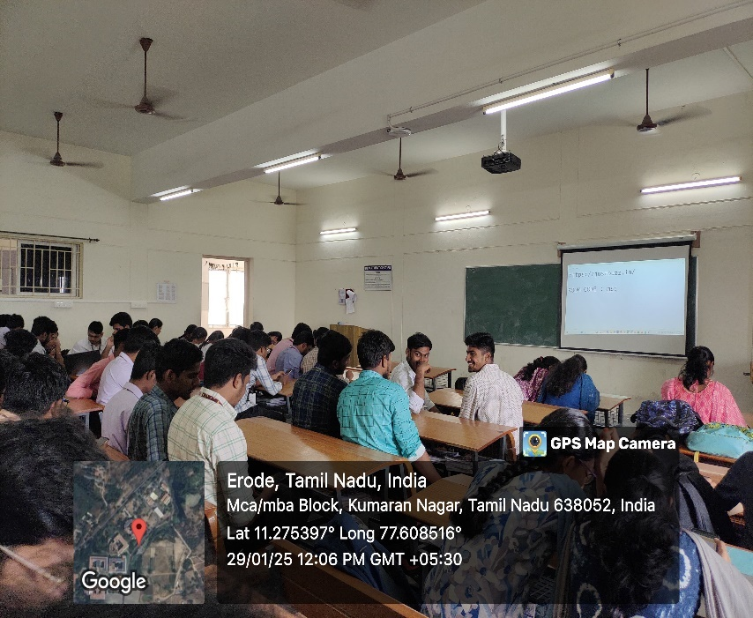

ROUND 2:

